CHOX Load Test Results Summary and Analysis

Introduction
Load tests have been developed for CHOX to enable the comparison of the performance (in terms of latency, throughput, failure rate) of different version of CHOX under stress.

Test Plan Overview
The test plan consists of 6 distinct thread groups, which run simultaneously and perform the following actions:
- CHO Actions: this thread group mimics the general activity of a CHO user, searching, viewing and action claims, exporting the grid, claim file export, uploading and downloading attachments. The plan is configured to run with 20 CHO users, processing 5 distinct claims in 10 randomly chosen queues.
- CHO Bordereau upload and processing: a thread group that uploads and processes a CHO brodereau. This thread groups 20 consecutive users each uploading and processing a single bordereau.
- Insurer Actions: this thread group mimics the general activity of an Insurer user, searching, viewing and action claims, exporting the grid, claim file export, uploading and downloading attachments. The plan is configured to run with 20 Insurer users, processing 5 distinct claims in 10 randomly chosen queues.
- Insurer Bordereau upload and processing: a thread group that uploads and processes a manual brodereau. This thread groups 20 consecutive users each uploading and processing a single bordereau.
- Activity Monitoring: a thread group used to initiate requests indicating that a user is viewing a claim. The plan is configured to run with 20 users, each user making 20 monitoring calls while viewing 15 claims consecutively.
- Check Viewing Status: a thread group used to initiate requests indicating that a user is viewing search results (grid). The plan is configured to run with 20 users, each user making 20 monitoring calls while viewing 15 filters consecutively.

Summary
All 3 load tests severely stressed the test server with load averages in the range 25-30 for the majority of the test period.

On the previous production version of CHOX (CHOX v8.5.3), the test took 36 minutes and generated 670 errors:
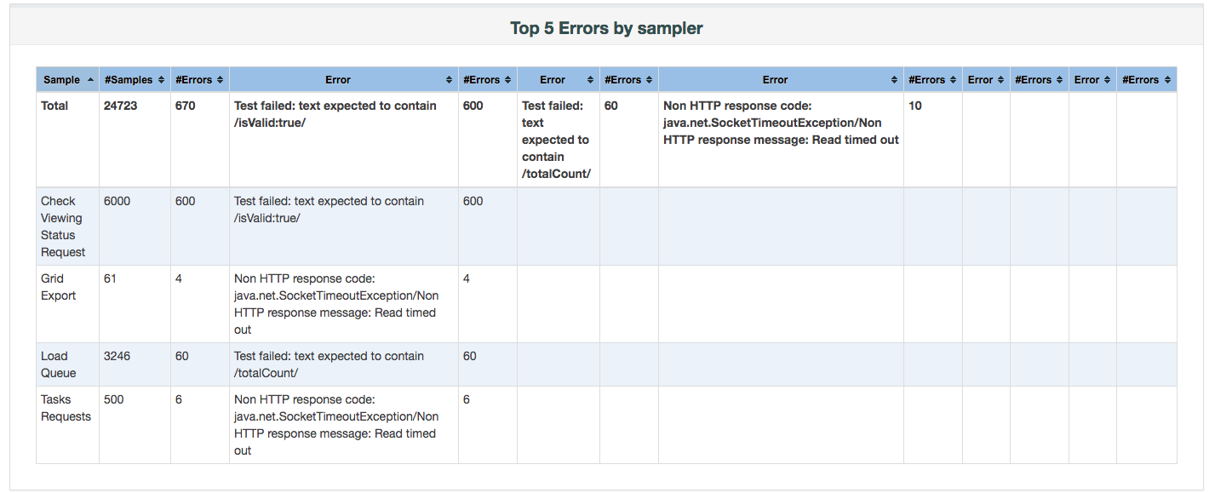
As can be seen, the majority of errors relate to the activity monitoring functionality. This is due to a know problem that was fixed in CHOX v8.6. The response latencies for these requests shows this improvement:

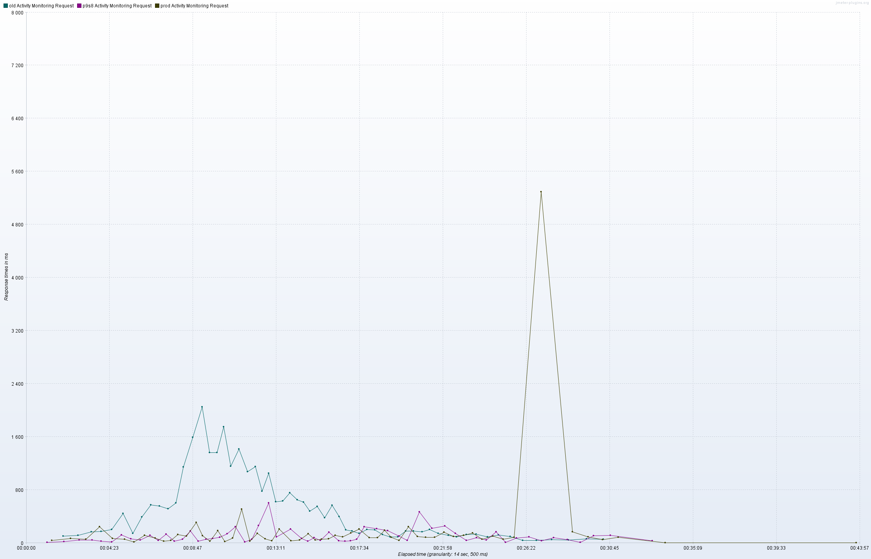

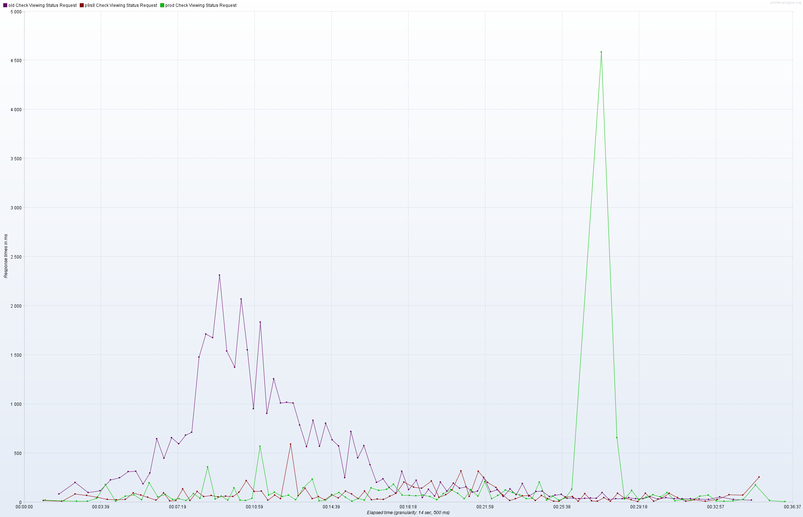

The production (CHOX v8.6.4) and Phase 9 Sprint 8 systems show a similar response profile. There is an out-laying point for the production system (> 4s) which corresponds to a STW GC pause.
The production (CHOX v8.6.4) tests took 51 minutes to complete and generated 32 errors, while the Phase 9 Sprint 8 tests took 46 mins and generated 41 errors:

CHOX v8.6.4:

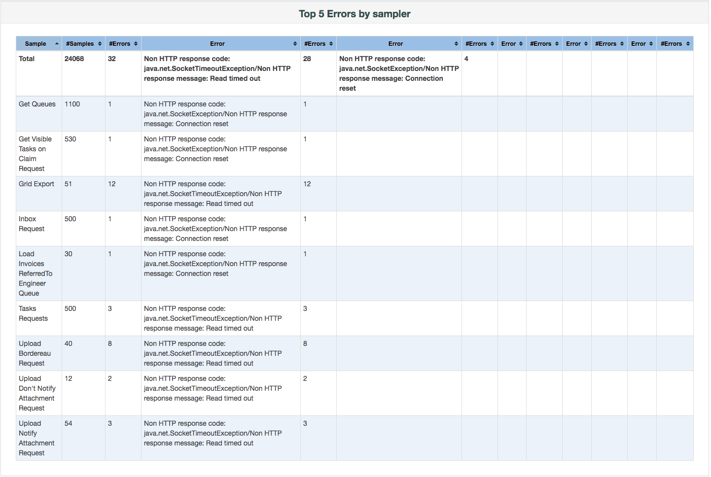

CHOX 8.7.rc1:

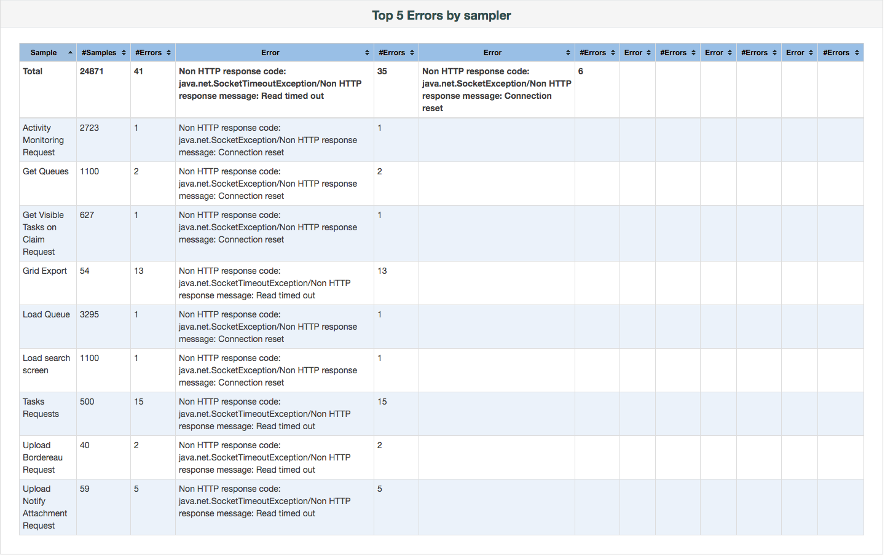
These errors are due to the tomcat server being unable to provide threads to service the requests due to the high load and are to be expected.

One point to note, however, is a general increase in response times between CHOX v8.5.3 and later versions:

CHOX v8.5.3:
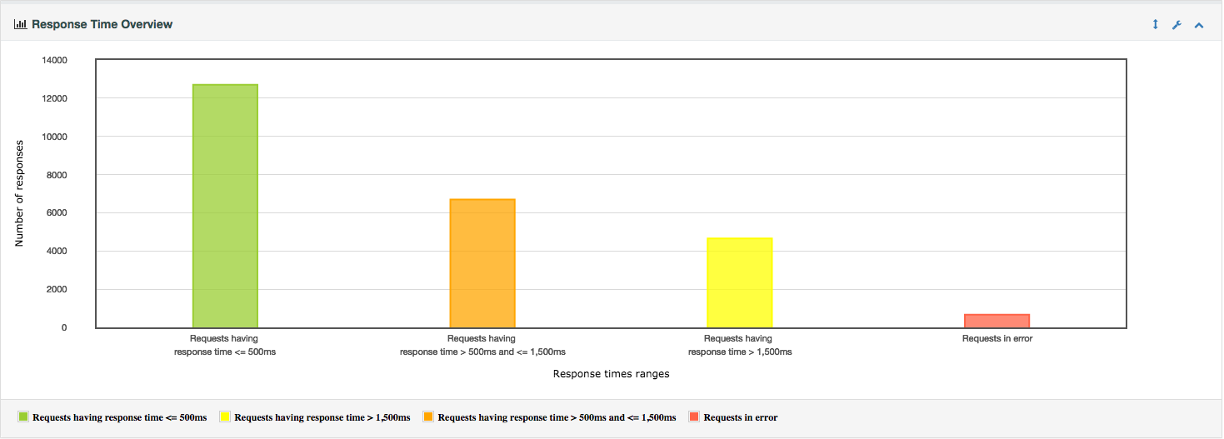

CHOX v8.6.4:
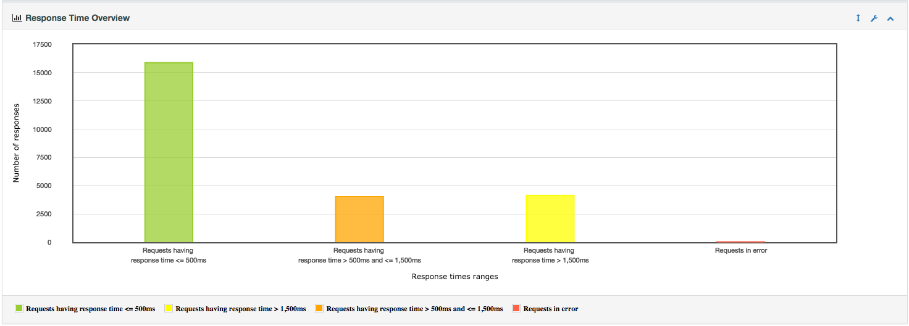

CHOX v8.7.rc1:
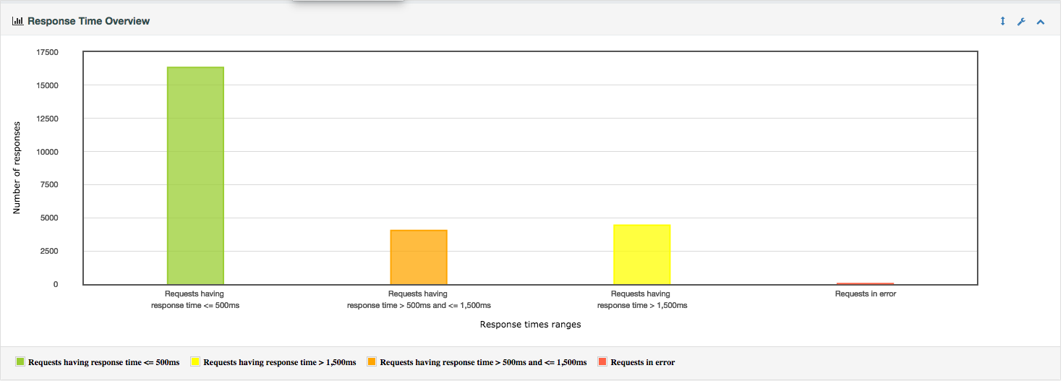

This increase can be explained by the addition of an ‘event bus’ which was added to CHOX in version 8.6. Since this release, all update requests also generate events which need to be handled and logged, increasing the response latency for all such requests.

The response latencies for ‘read’ requests (e.g. loading a filter, viewing a claim) are similar between the 3 different SUTs. Latency increases for these requests as the system is stressed (which is to be expected):

Inbox request comparison:
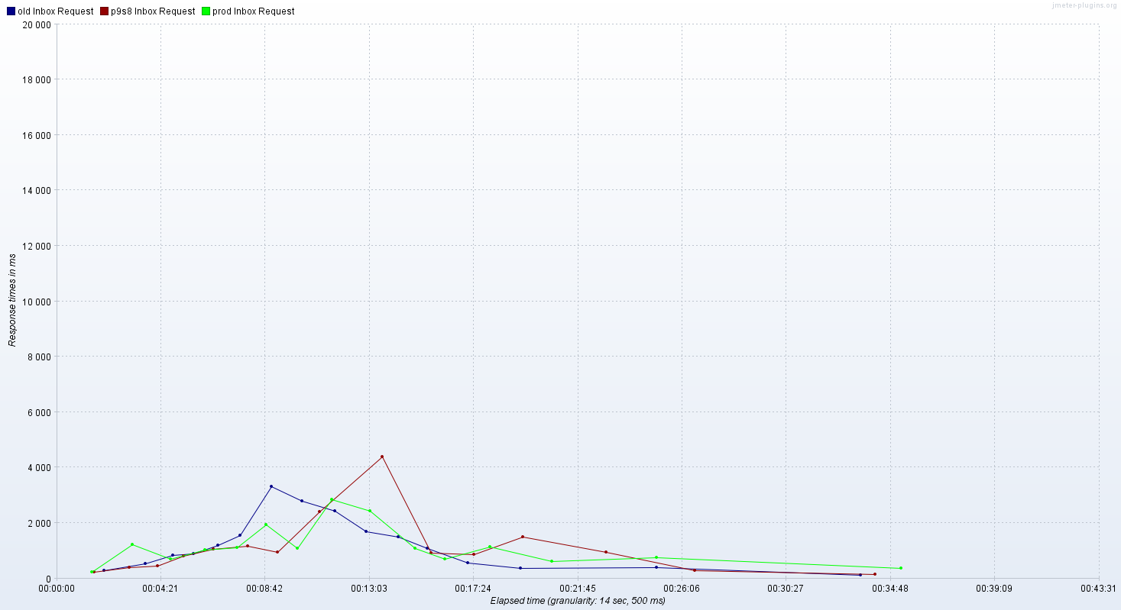

Load Queues:

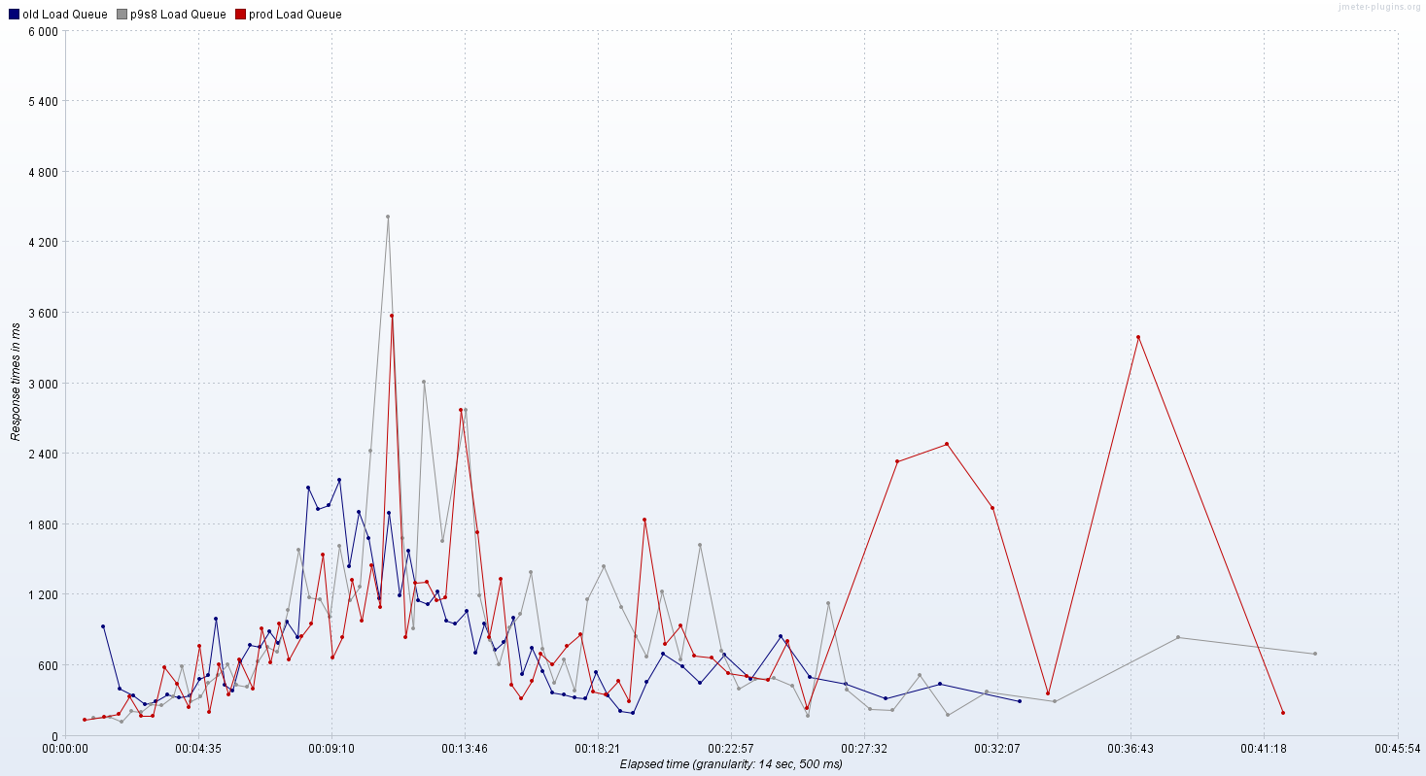

Load Claim:
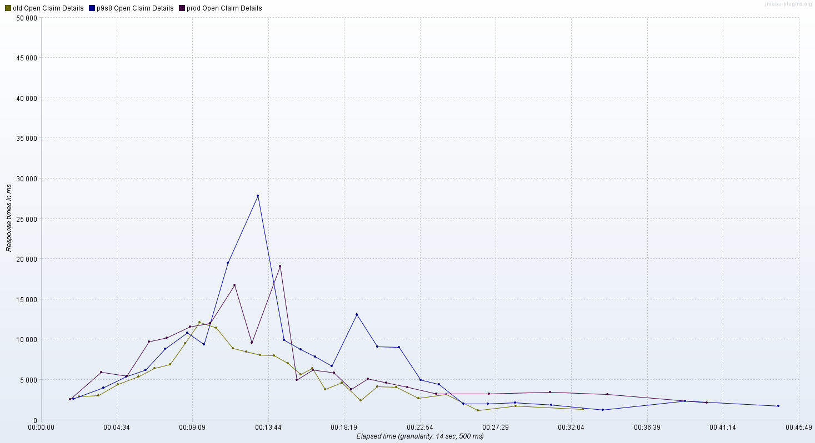

Further Notes and Actions
- There were two thread groups uploading bordereaus (one for insurer, one for CHO) for the duration of these tests, with a total of 40 bordereau upload/processing requests. This is not only extremely high but also implies that many of these bordereaus were uploaded simultaneously. This is known to stress the system and there is now a separate test for this scenario. As this is a general load tests and should reflect the standard system use, it would be better to just use once thread group to consecutively upload bordereaus for both CHOs and Insurers. A maximum of 10 bordereau uploads should also be sufficient for the duration of this test, and allow for substantial periods of high activity without bordereau upload/processing taking place.
- Activity monitoring (including check viewing status) requests constitute 90% of all requests on the production system. However, in these tests they only constitute 10% of requests. This needs to be addressed by increasing the number of activity monitoring/check viewing status users.
- The test plan should be updated to also allow for the monitoring of the system resources of the machine under test.
- The tests should be tuned to show responses during low/normal use as well as under high load. To this end, the ‘throughput shaping timer’ (jmeter add-on) should be used to allow the load/throughput to vary during the testing period.
- Tests to be performed on Java 8 release for SUT CHOX v8.7 only and comparison results generated.
- The default parameters used to calculate the APDEX need to be configured correctly to generate APDEX appropriate APDEX values for each request.

Java 8 Update
For the Java 8 load tests, the test plan has been updated to better reflect production usage. The changes made are:
- Only use one thread group for uploading and processing bordereaus (mixed for insurer and CHOs)
- Increase the number of activity monitoring/check viewing status threads/users

This changes the active thread usage from the previous load test results:

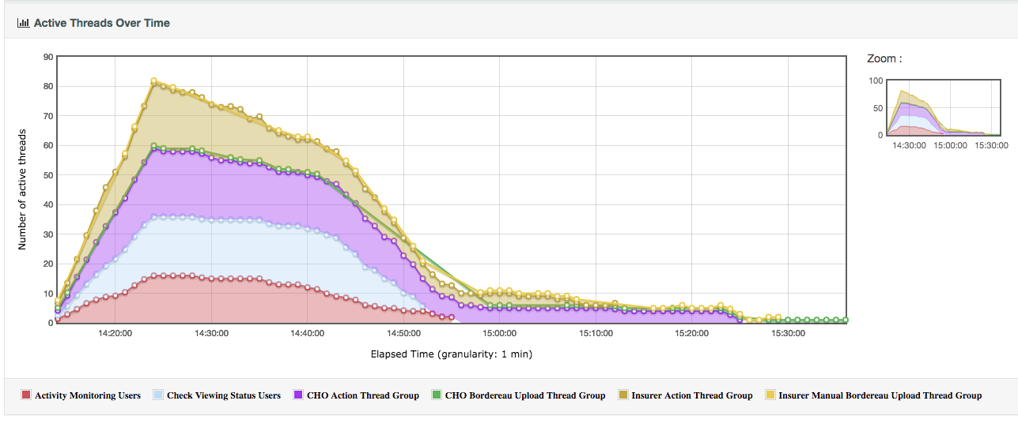

to the following:

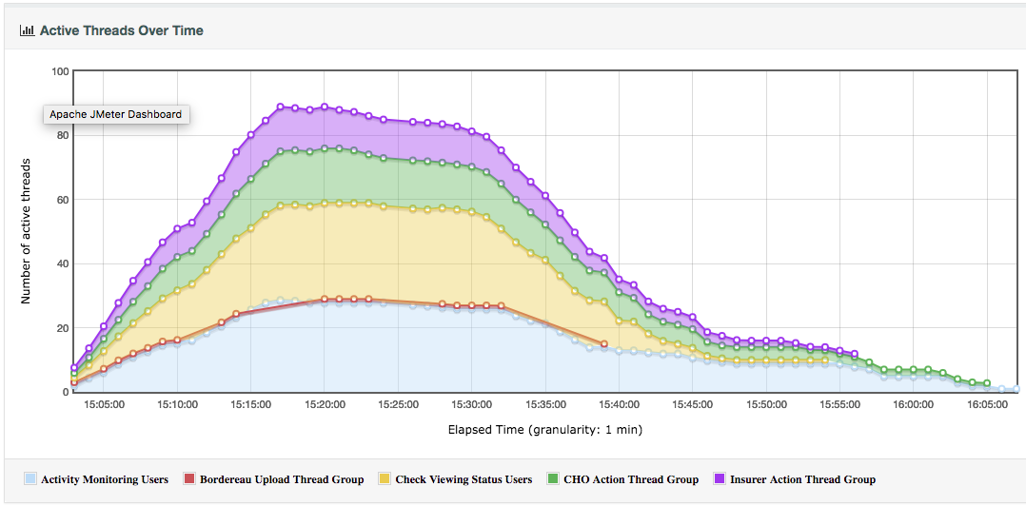

The updated test plan is executed on the following 3 CHOX systems (SUTs):
- Current release CHOX v8.7, compiled on Java 7 (i.e. current production system) and running under Java 7
- Current release CHOX v8.7, compiled on Java 7 (i.e. current production system) and running under Java
- CHOX v8.7.1, which is the current production version recompiled under Java 8 with the following dependencies updated (for Java 8):
- Postgres JDBC driver updated from 42.1.4.jre7 to 42.1.4.
- Hikari Connection Pool updated from 2.4.10 to 2.6.2

Results
The load tests took just over an hour to run on all three SUTs:
CHOX v8.7 (Java 7): 1 hour 3 mins
CHOX v8.7 (Java 8): 1 hour 4 mins
CHOX v8.7.1 (Java 8): 1 hour 6 mins
The following table summarizes the activities completed for each SUT:

 | CHOX v8.7 (Java 7) | CHOX v8.7 (Java 8) | CHOX v8.7.1 (Java 8)
Errors | 100 | 54 | 69
New Claims | 244 | 221 | 353
New Invoices | 7 | 6 | 7
Claims Modified | 630 | 635 | 757
Invoices Modified | 124 | 151 | 139
Claims Progressed | 610 | 581 | 644
Claims Reverted | 34 | 19 | 51
Events generated | 860 | 847 | 1032
Attachments uploaded | 60 | 66 | 71
Notes created | 419 | 442 | 567
Tasks created | 85 | 99 | 101
Claim Export | 125 | 135 | 139
Grid Export | 52 | 53 | 50

This shows that there were significantly more updates under the Java 8 versions, especially the v8.7.1 version. The v8.7.1 version also experienced 1 authentication failure, which would also have invalidated the remaining requests for that thread/user.

Almost all errors were due to socket timeouts due to heavy load. These correspond to the periods where the SUT was ‘out of database connections’. CHOX v8.7 under java 7 had connection contention between the +17minute mark until the +26minute mark, and ran out of connections 54 times over this 9 minute period, whereas the CHOX v8.7.1 version (under Java 8) had connection contention between the +16minute mark until the +23minute mark, but only ran out of connections 48 times in a 50 second period.

GC Activity
Looking at the GC activity for the SUTs, we can see the following:
CHOX v8.7 on Java 7:
Total GC Time: 4 mins 58 seconds
Number of GCs: 394
Average GC interval: 17sec
# GC pauses > 10s: 8 (28s, 25s, 22s, 17s, 14s, 13s, 11s, 11s)
CHOX v8.7 on Java 8:
Total GC Time: 9 mins 6 seconds
Number of GCs: 1132
Average GC interval: 18sec
# GC pauses > 10s: 6 (110s, 25s, 20s, 19s, 16s)
CHOX v8.7.1 on Java 8:
Total GC Time: 11 mins 6 seconds
Number of GCs: 1138
Average GC interval: 17sec
# GC pauses > 10s: 3 (162s, 80s, 29s)
This shows that the GC handling under Java 8 is quite different than that on Java 7, with a huge increase in the number of GCs and also a huge increase in the maximum GC time. Almost all of the timeout errors on the CHOX v8.6.1 version occurred around the 162 second STW GC pause.

CHOX v8.7 on Java 7:
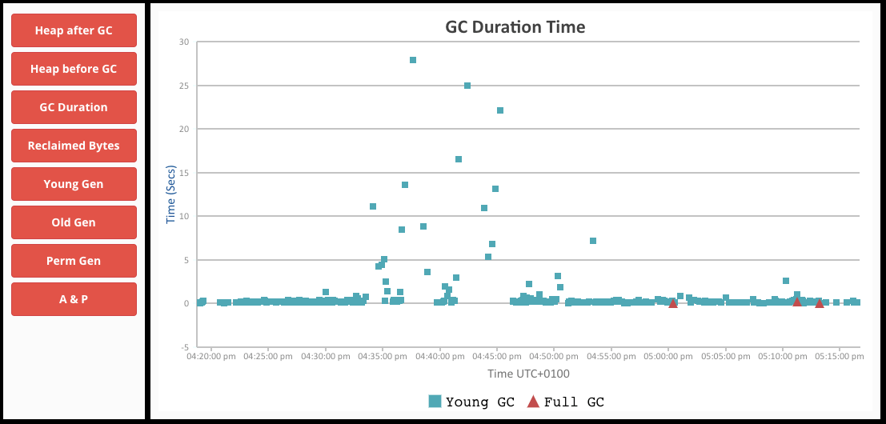

CHOX v8.7 on Java 8:
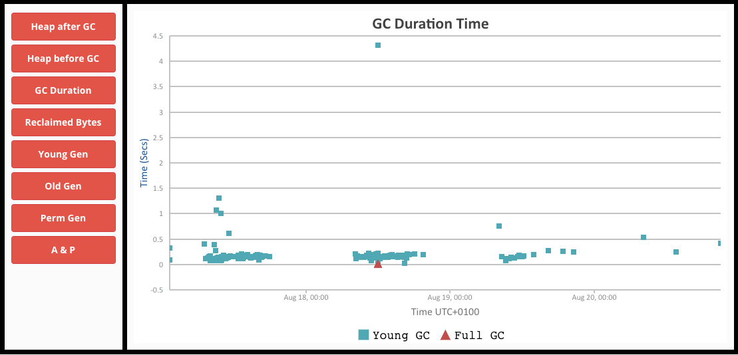

CHOX v8.7.1 on Java 8:
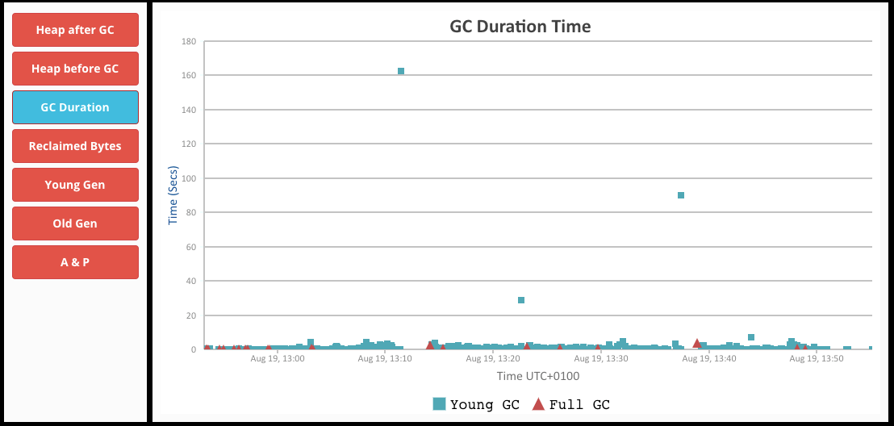

It should be noted that GC behavior on Production is quite different to that shown here. However, as large GC pauses are one of the main causes of errors they need to be mitigated by tuning the GC activity. As these results show a significant change in behavior with regards to GC activity, the GC behavior should be monitored and tuned once the production system has been switched to Java 8.

For comparison, current production GC duration is as follows:

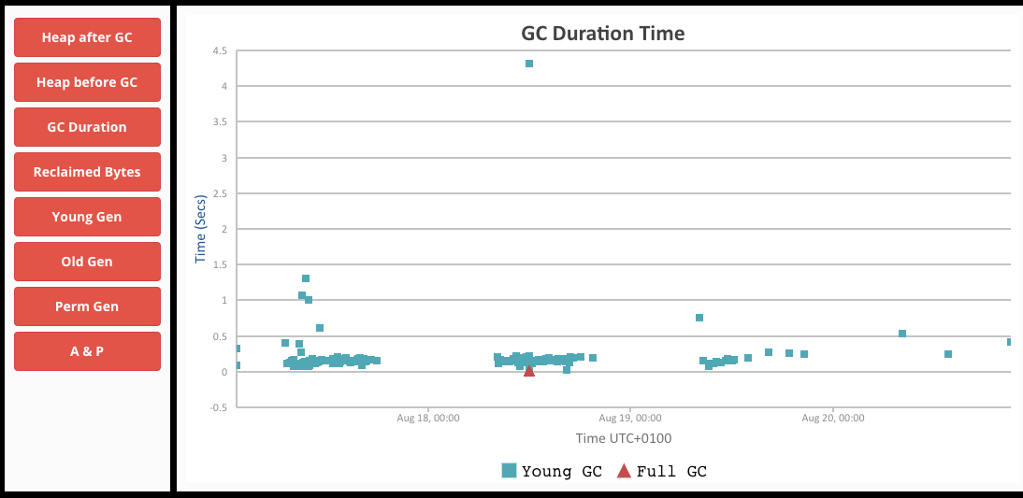

Response Times
[NB. Please note that in the graphs, the newly compiled Java 8 version is stated as 8.6.1 when it should be 8.7.1]

The following graphs show an overview of the response times for each SUT.

CHOX v8.7 on Java7:
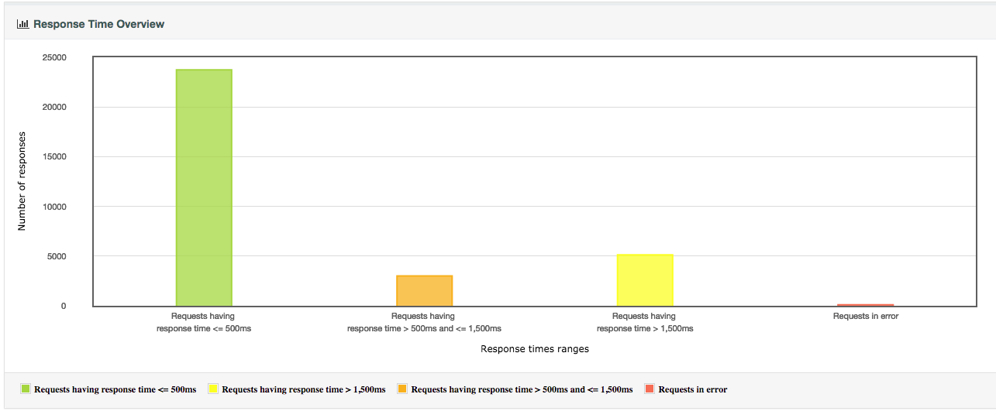

CHOX v8.7 on Java 8:
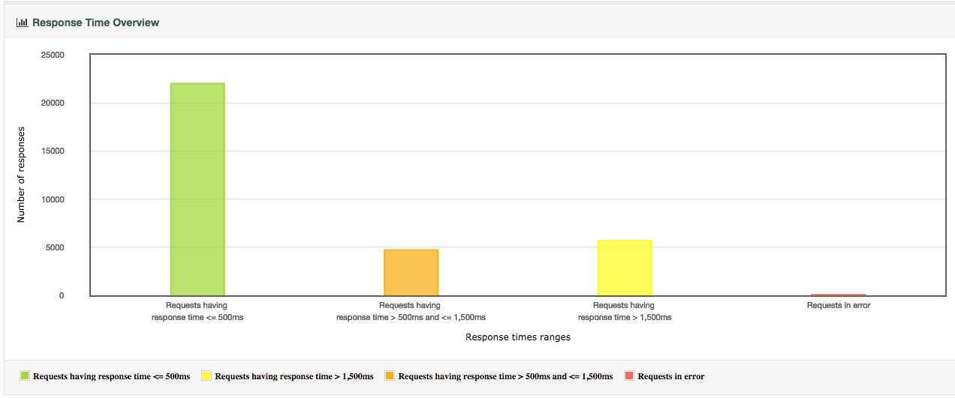

CHOX v8.7.1 on Java 8
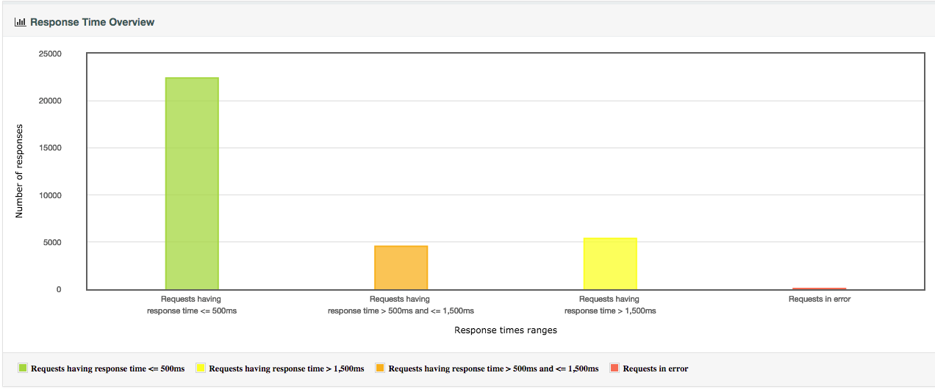

These show an overall slight increase in response times for the SUTs under Java 8. However, this mainly looks due to the two large GC pauses, and if these are taken into account then the response times are similar in the different SUTs, and many are actually better under Java 8.
The below graphs show individual comparisons for the 3 SUTs for different requests (I have also included these graphs with only the CHOX v8.7 on Java 7 and v8.7.1 on Java 8 SUTs for clarity):

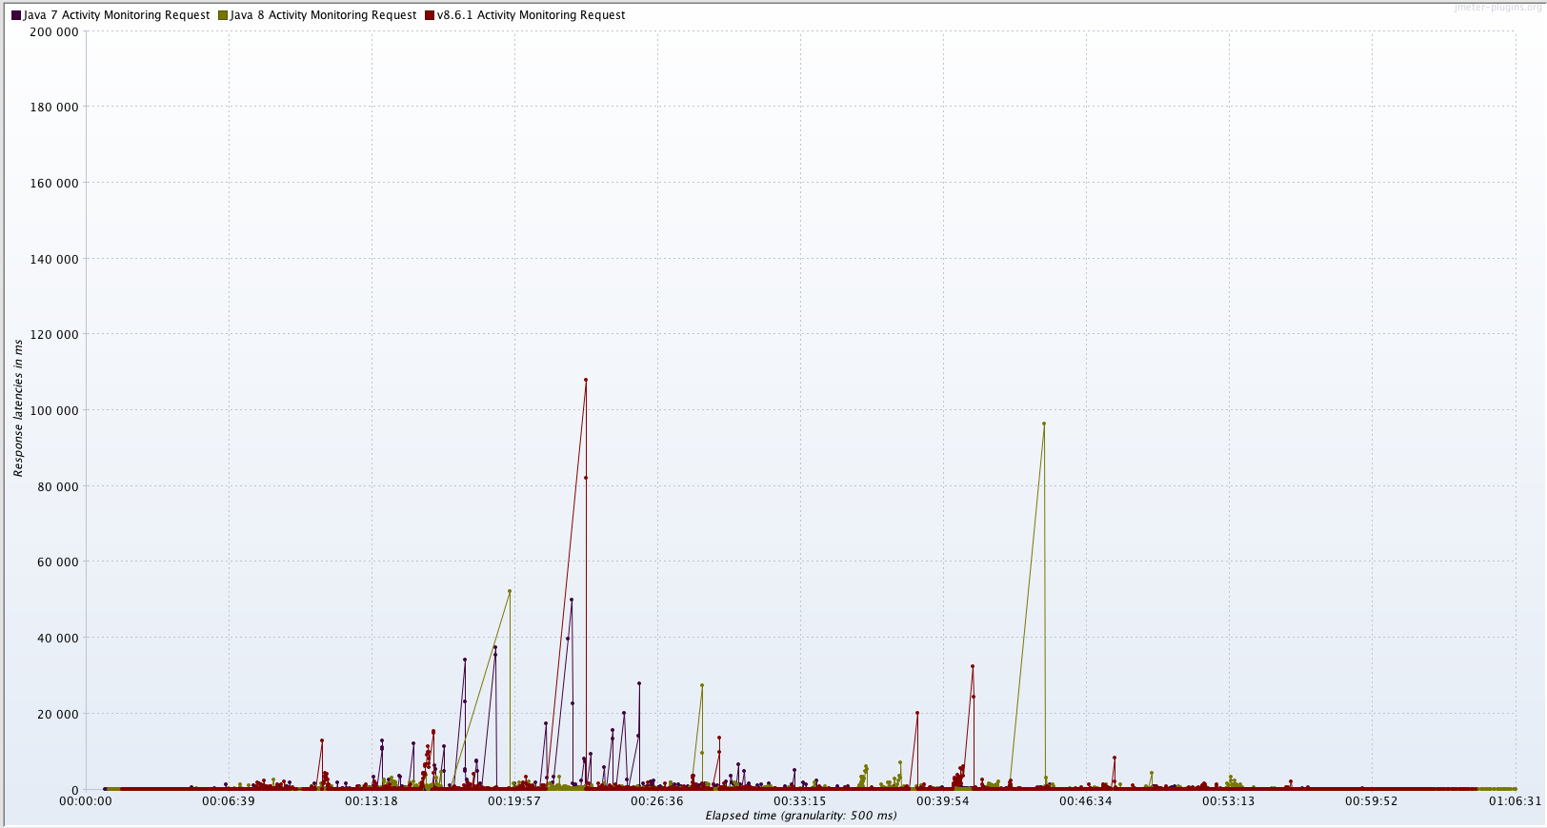

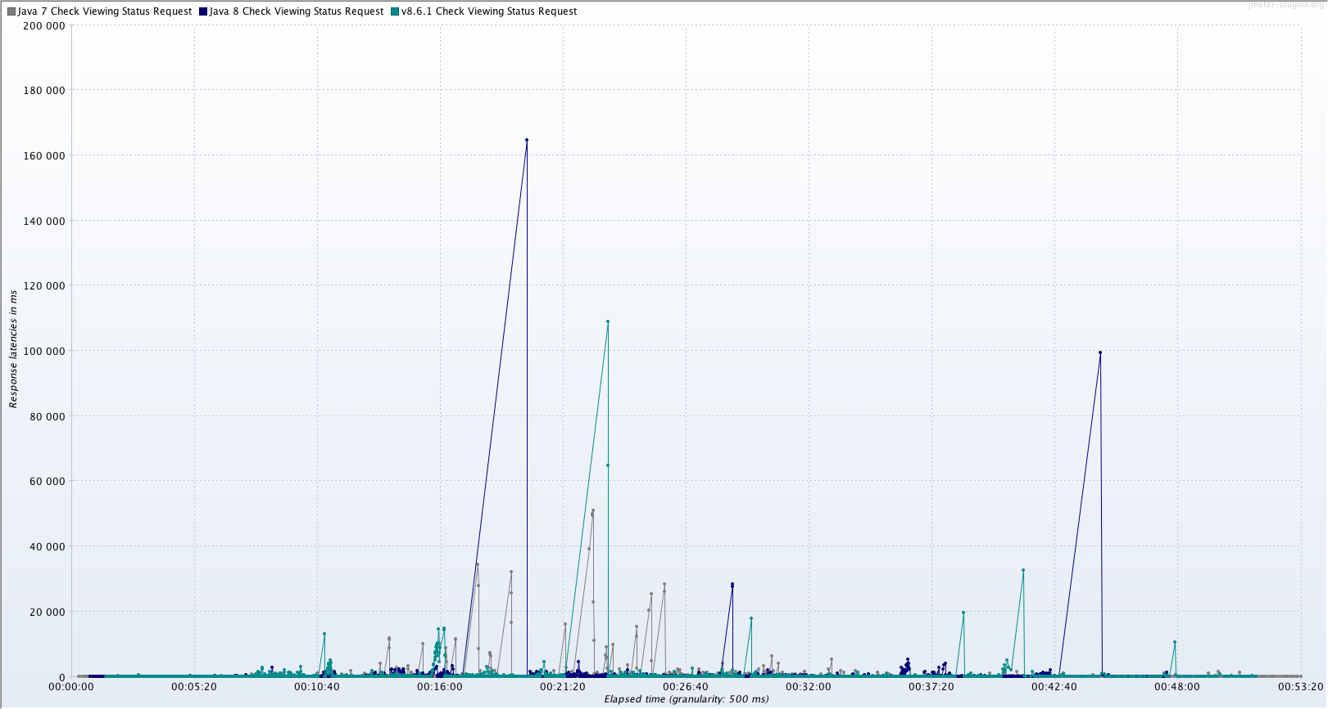

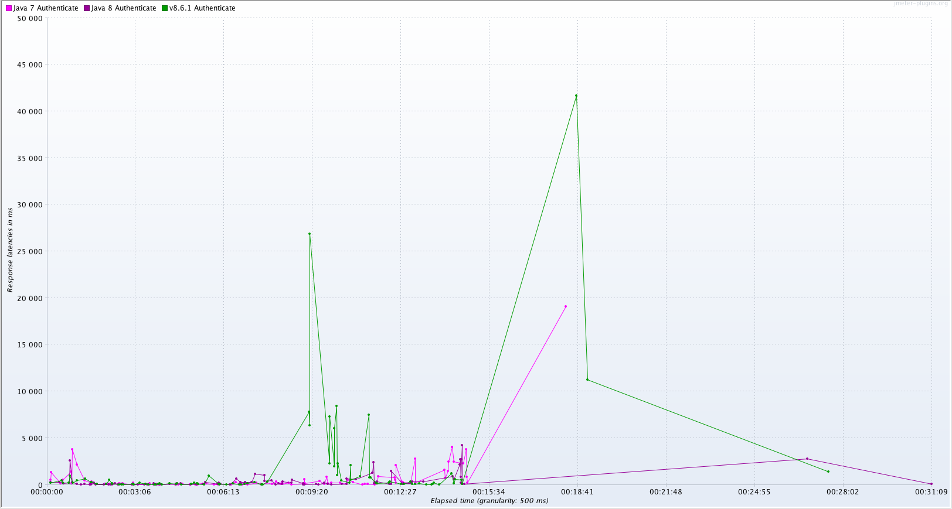
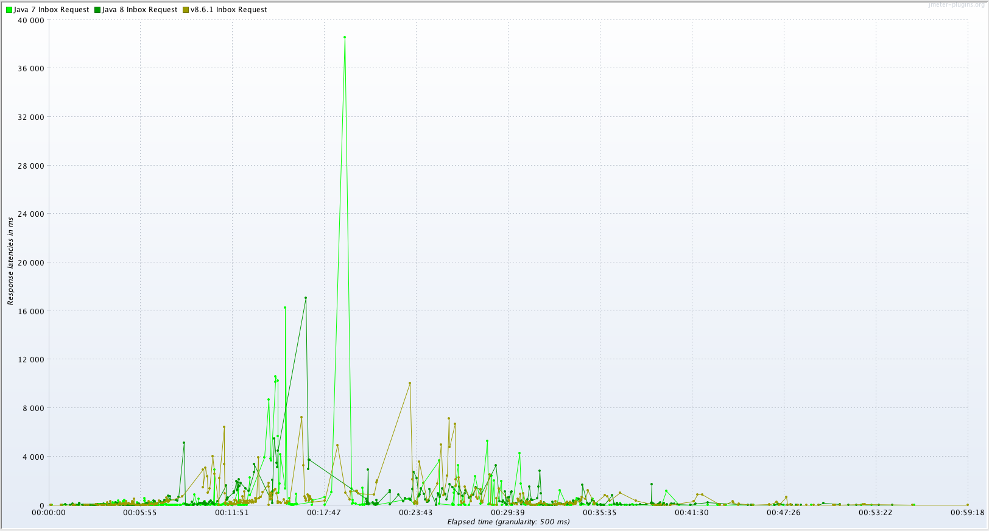
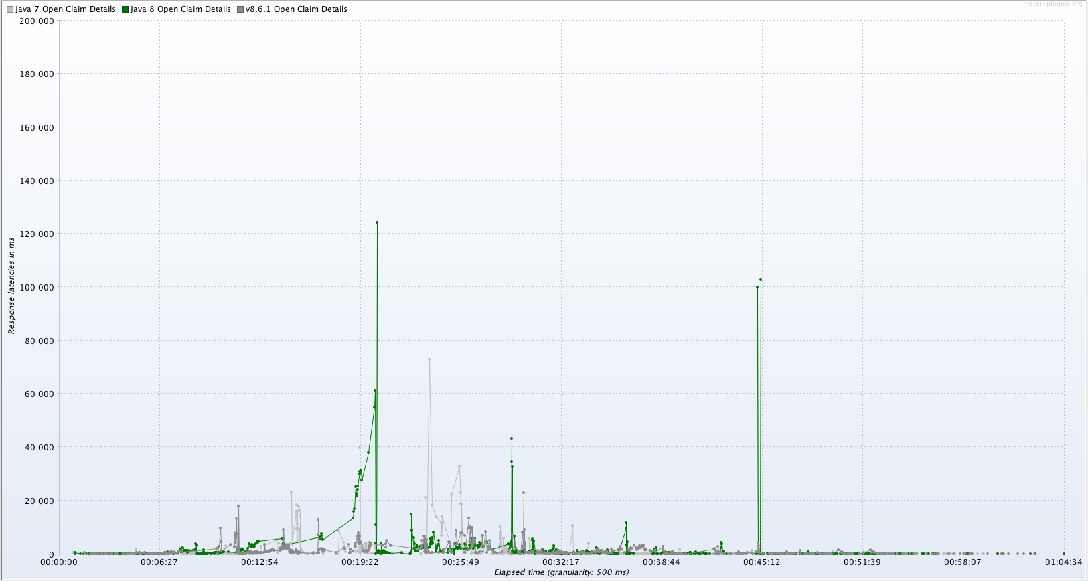
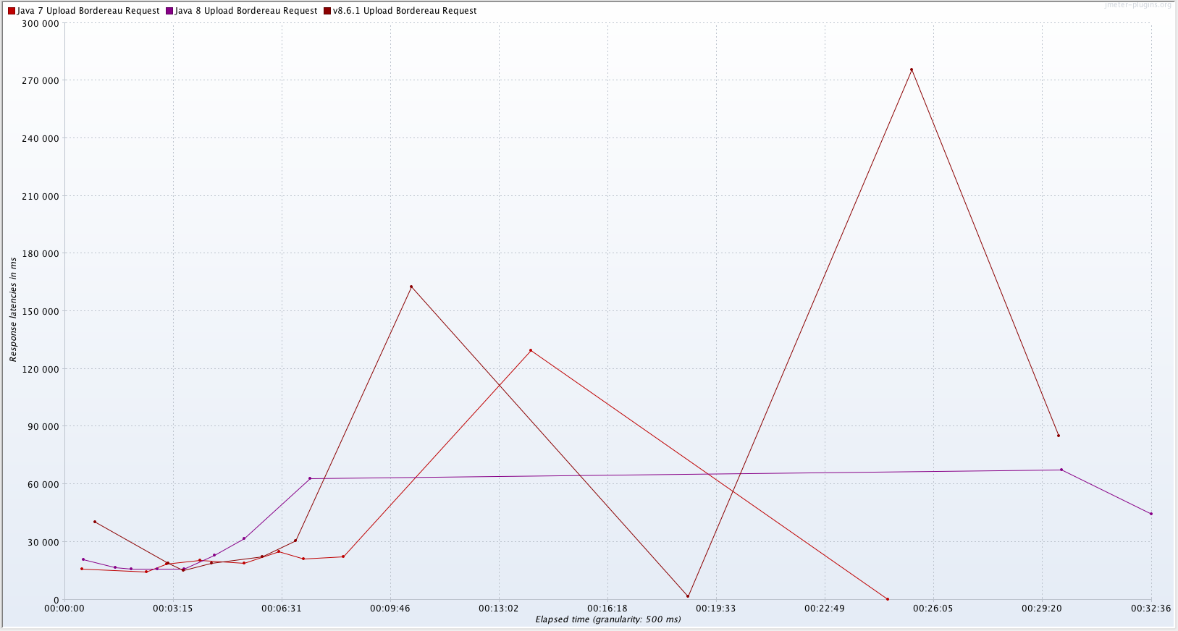
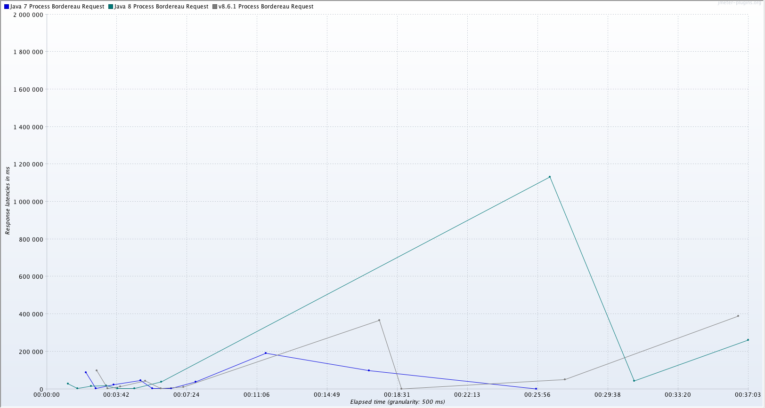
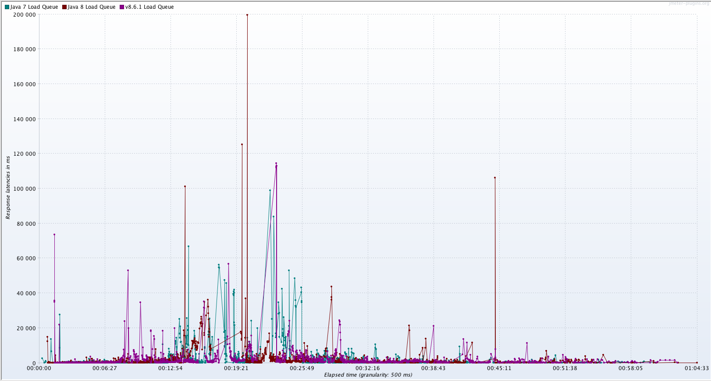
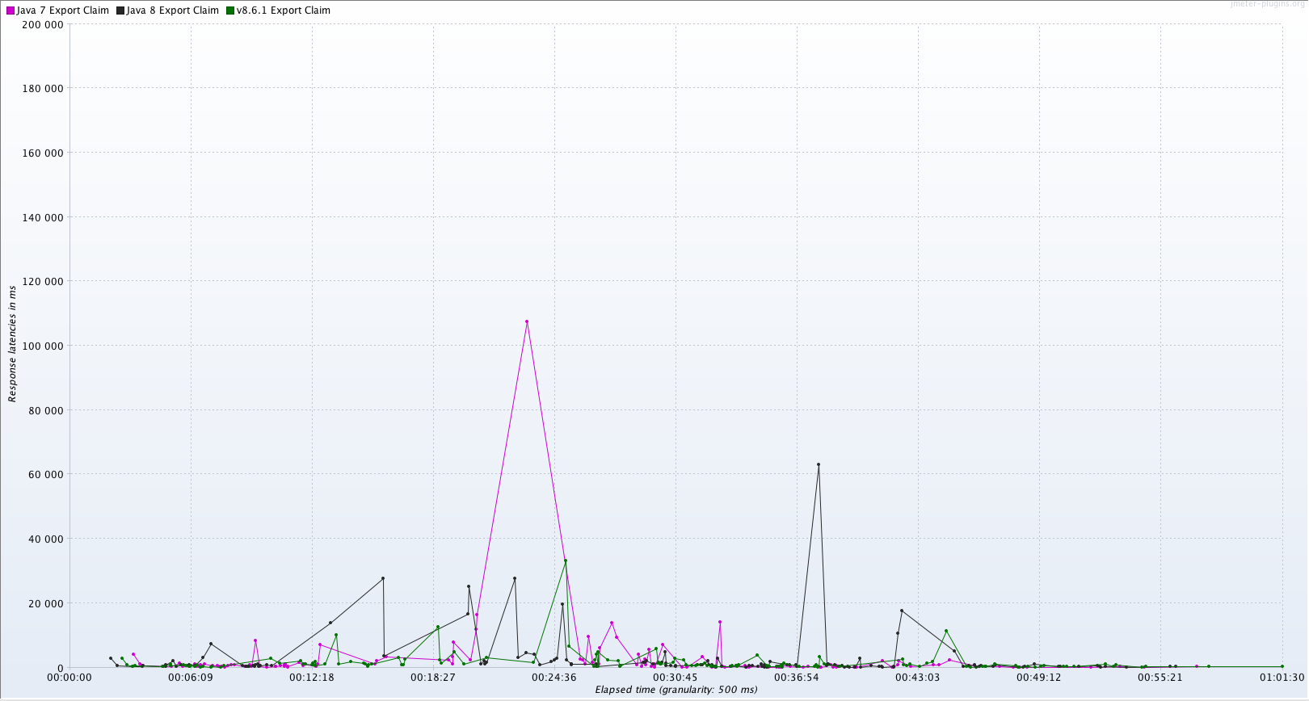
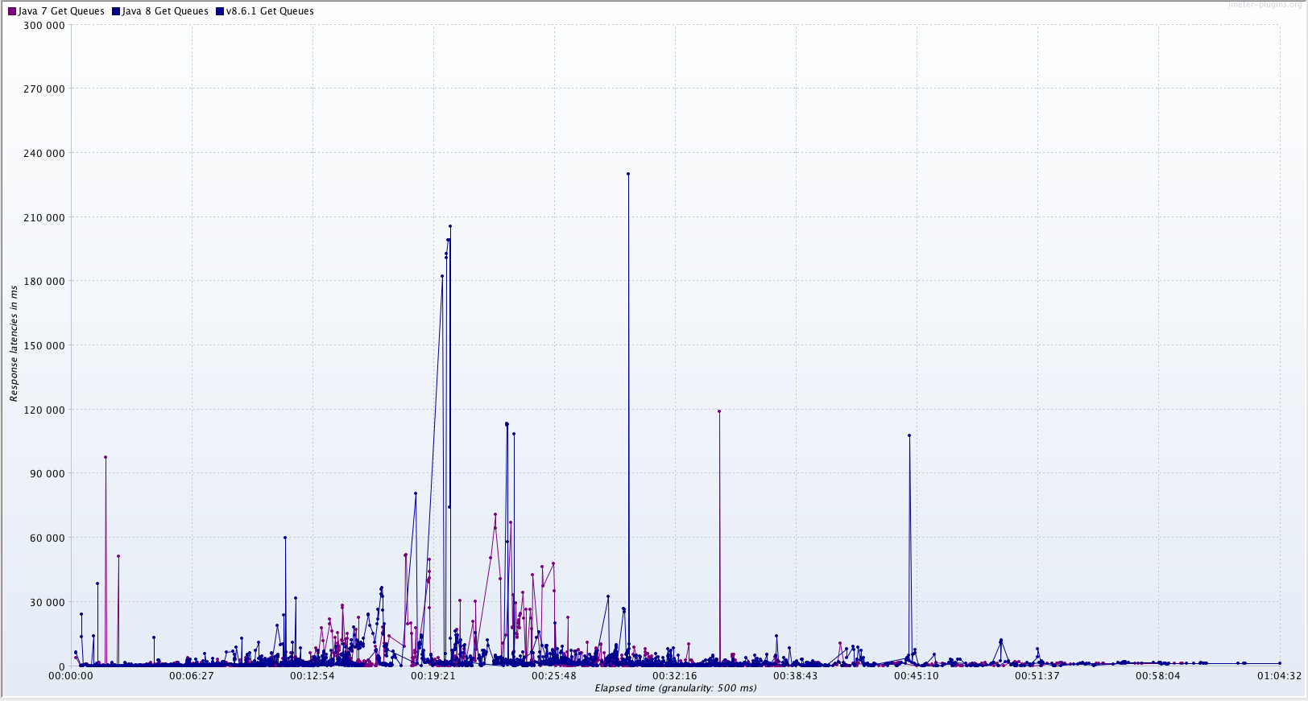
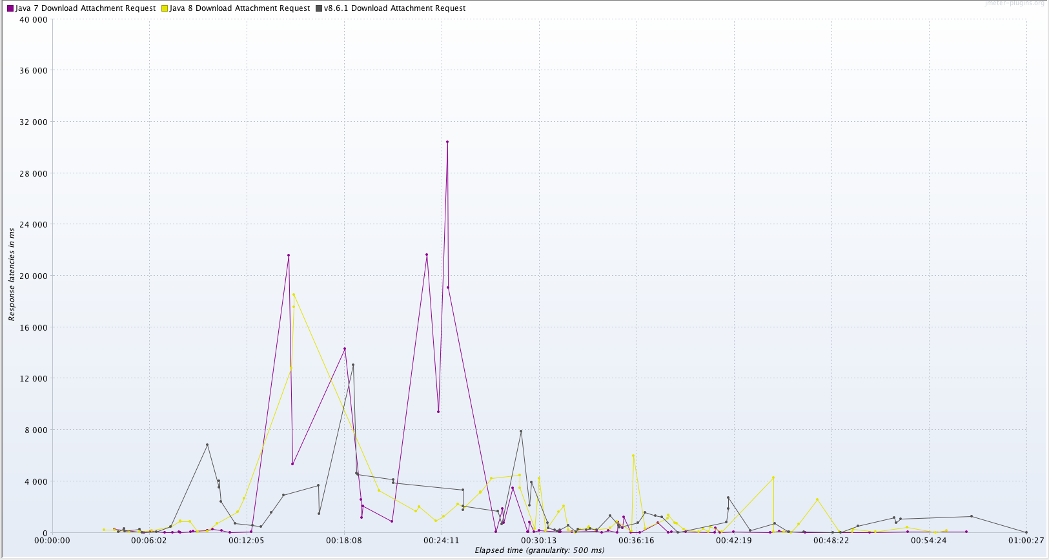
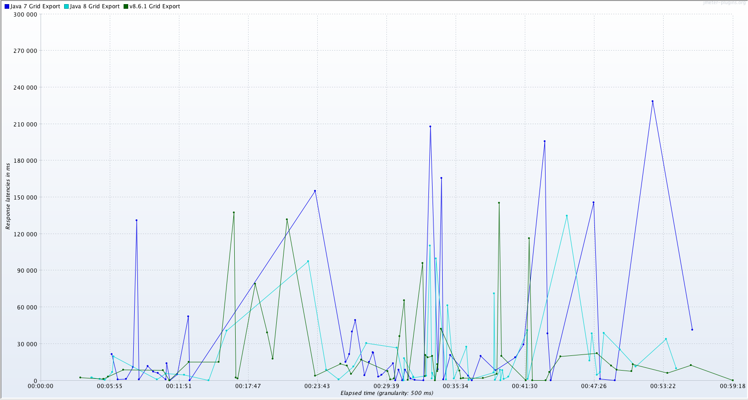

Summary
These results show that CHOX performs well under load on Java 8. The response times are generally the same or better, although in some scenarios there is an increase in the response times. The main are of concern is the GC handling under Java 8. Recommendations are:
- CHOX should be updated to run under Java 8, including the updates to the Postgres JDBC driver and the Hikari CP pool.
- The memory should be increased from 15G to 18G.
- GC behavior should be monitored and tuned once released
- Connection Pool handling should be monitored

Appendix A: Response Latency Comparison for CHOX v8.7 on Java 7 and CHOX v8.7.1 on Java 8 Only
